Steps of creating Vnet in Azure

1. Create a Resource Group

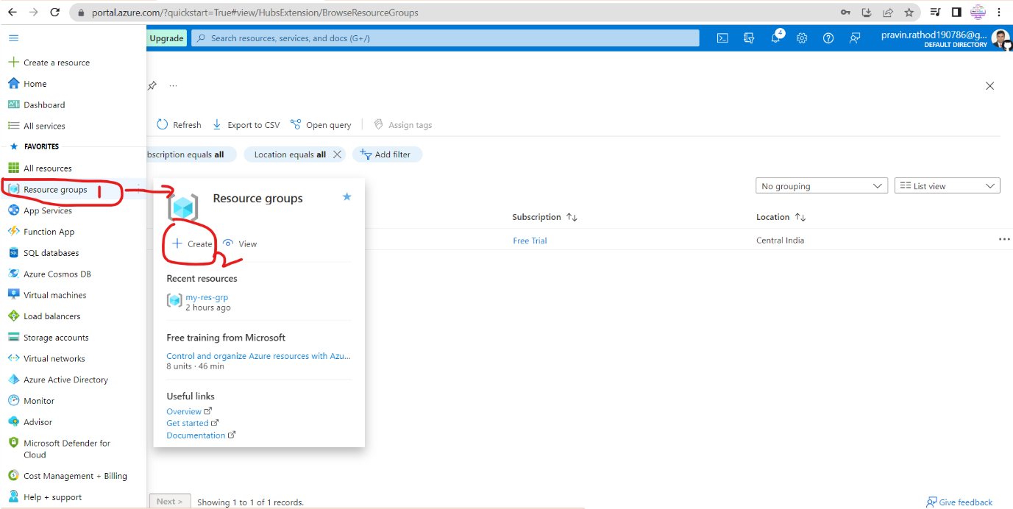

1. k